IN-LAB EXERCISE:
OBJECTIVE:
To implement and optimize linear regression and logistic regression models using real-world datasets and analyze their performance.
SCENARIO 1:
Predict ocean water temperature using environmental and depth-related features.
Dataset (Kaggle – Public): https://www.kaggle.com/datasets/sohier/calcofi
Target Variable:
· Water Temperature (T_degC)
Sample Input Features
· Depth (m)
· Salinity
· Oxygen
· Latitude
· Longitude
IN-LAB TASKS
• Import necessary Python libraries (NumPy, Pandas, Matplotlib, Seaborn, Scikit-learn).
• Load the CalCOFI dataset into a Pandas DataFrame
• Select relevant numerical features and target variable.
• Handle missing values using mean/median imputation.
• Perform feature scaling using StandardScaler.
• Split the dataset into training and testing sets.
• Train a Linear Regression model using Scikit-learn.
• Predict water temperature for test data.
• Evaluate model performance using: – Mean Squared Error (MSE) – Root Mean Squared Error (RMSE) – R² Score
• Visualize: – Actual vs Predicted temperature – Residual errors
• Optimize model performance using: – Feature selection – Regularization (Ridge / Lasso)
Output:
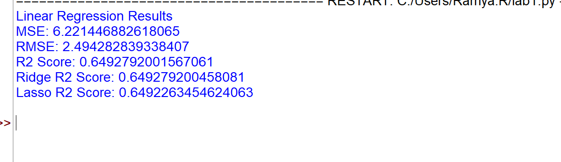
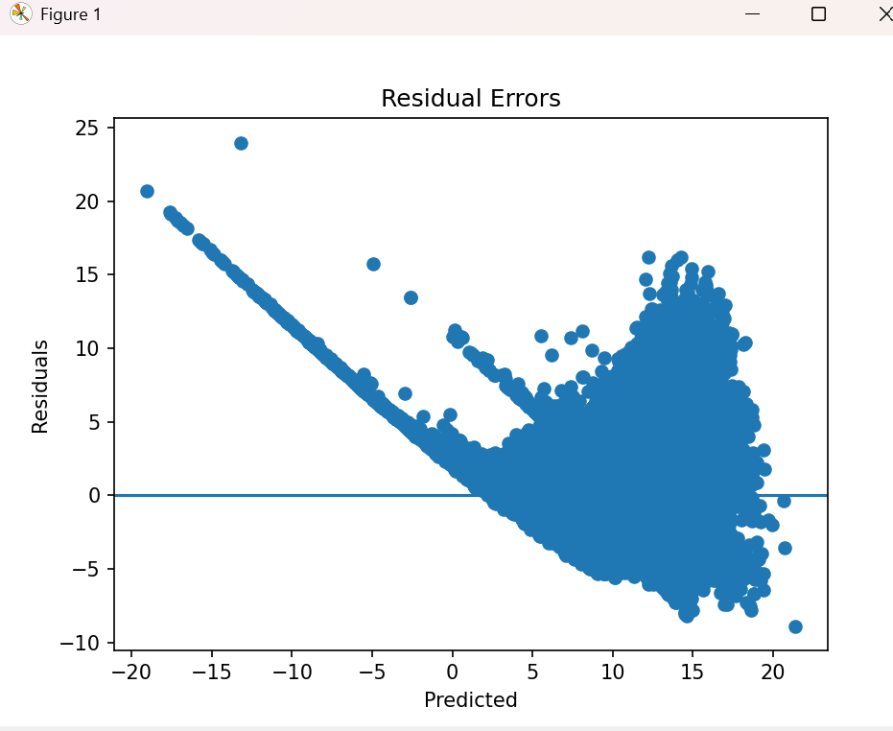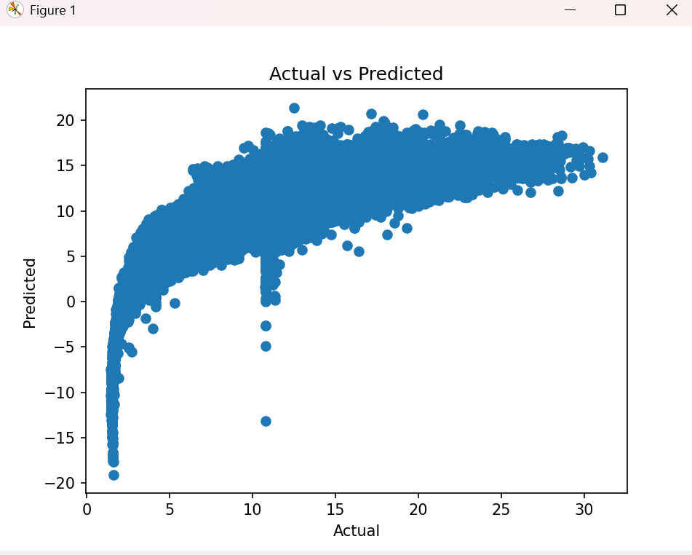

SCENARIO 2:
Classify whether LIC stock price will increase (1) or decrease (0) based on historical data.
Dataset (Kaggle – Public): https://www.kaggle.com/datasets/debashis74017/lic-stock-price-dataTarget Variable (Derived):
• Price Movement – 1 → Closing price > Opening price – 0 → Closing price ≤ Opening price
Input Features: • Open • High • Low • Volume
IN-LAB TASKS (Logistic Regression):
• Import required Python libraries.
• Load LIC stock dataset into Pandas.
• Create a binary target variable (Price Movement).
• Handle missing values.
• Perform feature scaling.
• Split the dataset into training and testing sets.
• Train a Logistic Regression model.
• Predict stock movement for test data.
• Evaluate classification performance using: – Accuracy – Precision – Recall – F1-Score – Confusion Matrix
• Visualize: – ROC Curve – Feature importance
• Optimize model using: – Hyperparameter tuning (C, penalty) – Regularization

